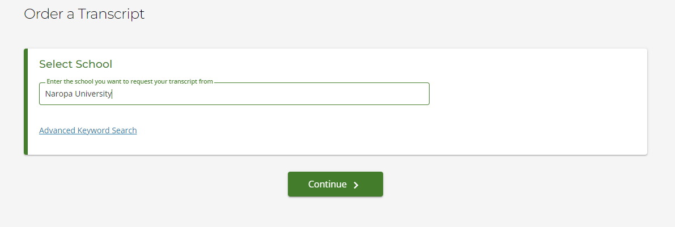
- Enter Naropa University, then select “Continue”
- Please read the note regarding processing times and uploading additional documents
- Scroll down and select “Order Transcript(s)”
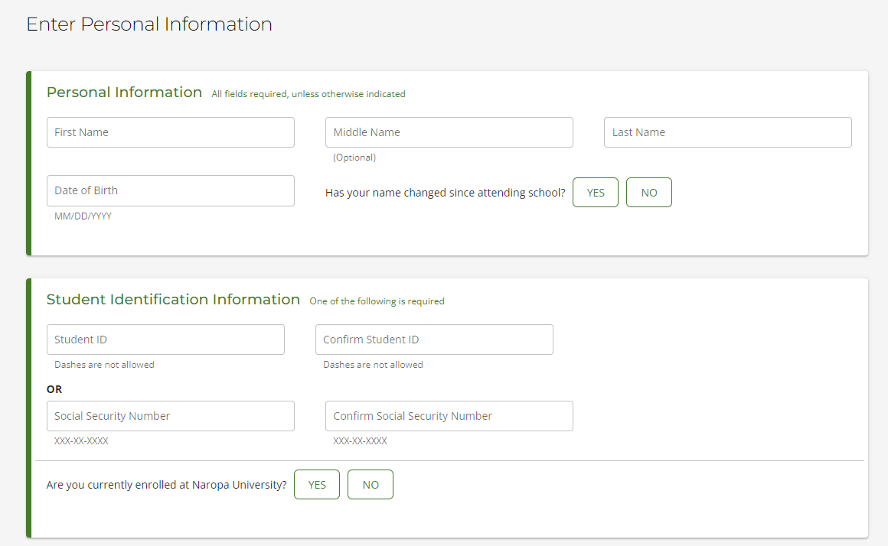
- Enter your personal information, including whether or not your legal name has changed
- Enter your student identification information
  - You only need to enter ONE of these options. If you do not know your student ID, you can just enter your SSN.
- Are you currently enrolled at Naropa University? Yes or No
- Select “continue”
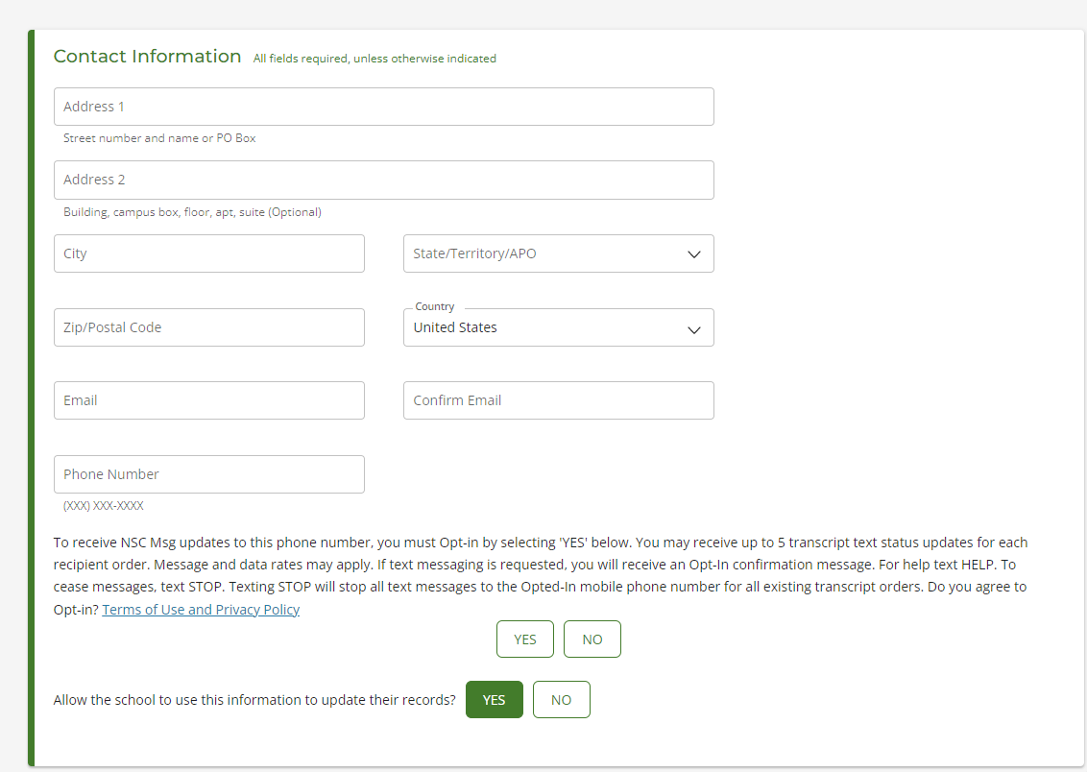
- Enter YOUR address and contact information
- Answer the yes or no questions, then select “continue”
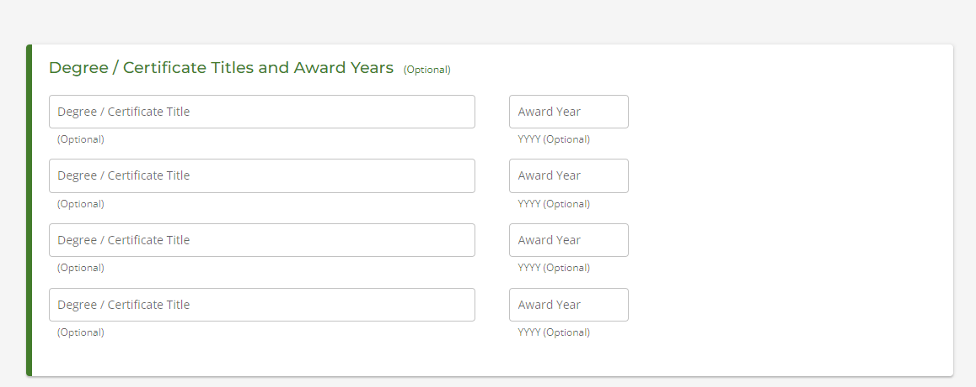
- Enter degree information. This is OPTIONAL. Then, select “continue”
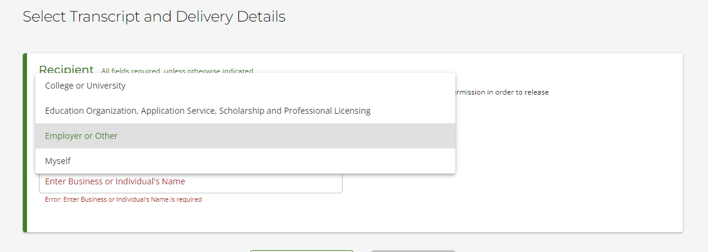
- Select the recipient
  - College or University – if you do NOT see your school listed, please select “Not in List”
  - Education Organization, Application Service, Scholarship and Professional Licensing – if you do NOT see your school listed, please select “employer or other”
  - Employer or Other – Enter name of business or individual
  - Myself
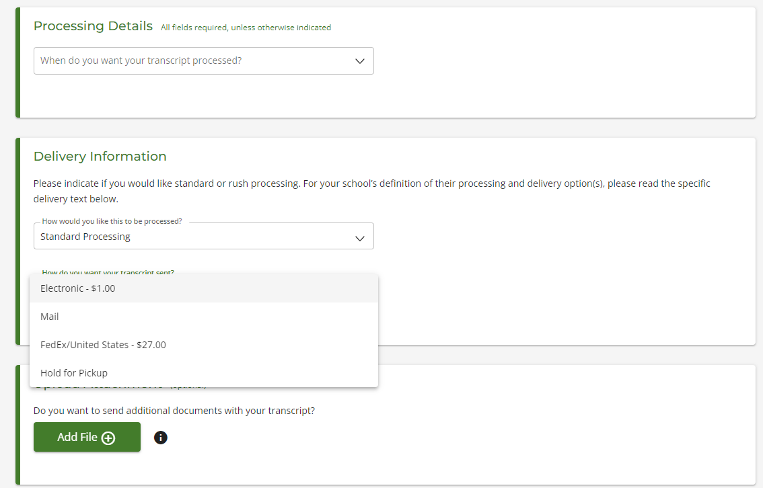

- Select when you want your transcript processed
  - If you select “After Degree is Awarded” or “After Grades are Posted” keep in mind, there will be a delay in processing
- Select delivery method
  - Rush processing will be 1-2 business days faster than standard processing
  - Please keep in mind that transcripts sent by mail are processed once per week
- How do you want your transcript sent?
  - Electronic
    - Cannot be used for transcripts requiring an Apostille
  - Mail
  - FedEx/United States
  - Hold for Pickup
- Upload additional attachments if needed, then select “continue”
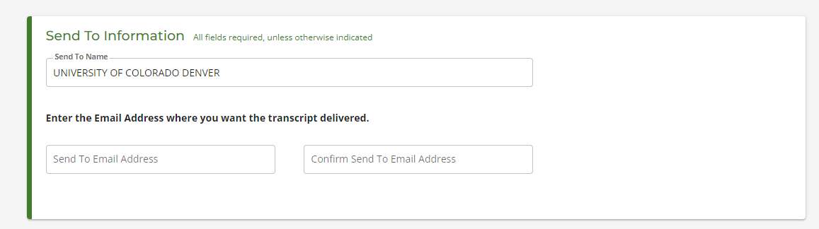
- If you chose electronic, you will need to double check the name, and enter the email address of the recipient.
- If you chose mail, you will need to double check the name, and enter the physical address of the recipient.
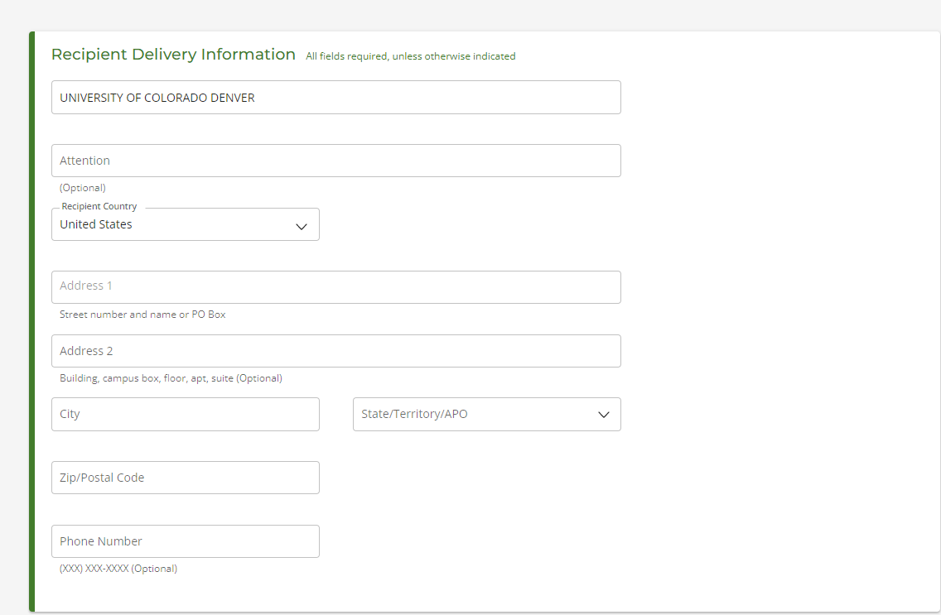
- Select add to cart
- Select checkout
- Sign the consent, and continue to the payment page to place your order.
If you have any questions, or run into any issues, please email registration@naropa.edu

